
Land Information Ontario (LIO) Warehouse
Data Class Name: Aggregate Inspector Jurisdiction
Documentation
Produced by: Information Access and Information Management Policy Unit
Ministry of Natural Resources and Forestry
Date: July 27, 2015

Purpose

This document provides additional information to support the use of geospatial data. The Physical Model Diagram provides a visual representation of the relationships in the data class. The Data Change History lists all the modelling and access changes that have occurred during the lifecycle of the data class. A data description identifying table and field names is available upon request.

Need Assistance?
Please contact LIO Support at lio@ontario.ca or 705-755-1878 if you require help.

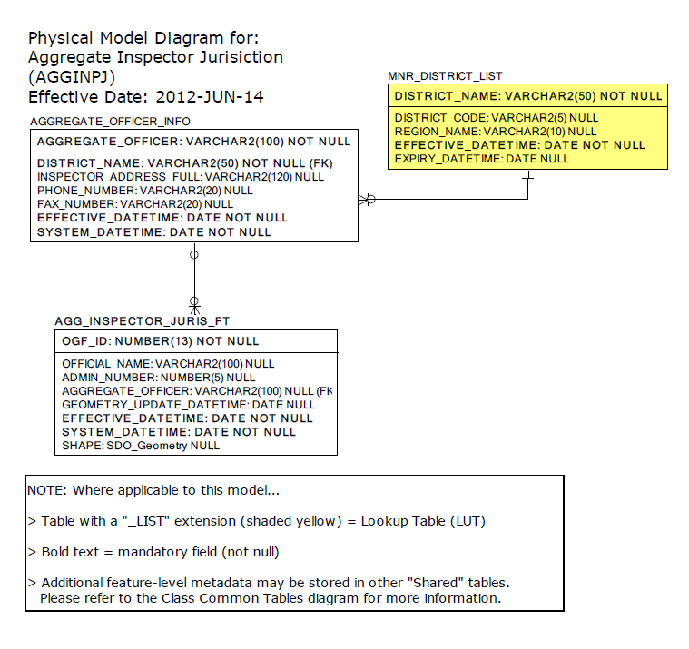

Data Class Change History

Data Class Name: Aggregate Inspector Jurisdiction
Data Class Short Name: AGGINSPJ
Date  YYYY-MM-DD | Details of Change
2009 | 5 new attributes added at Information Owner’s request so that they may add contact details for Aggregate Inspectors. Please note that storing this basic Crown Employee information does not contravene Freedom of Information and Protection of Privacy Act (FIPPA) guidelines.
2005 | Data Class conversion: Aggregate Inspector Jurisdiction  Convert this NRVIS/OLIW layer from a 'Standard' data class to a 'Simple' data class. This means that the feature class table will not be associated to the GEOG_UNIT table. The only GEOG_UNIT table attributes retained in the Feature Class table is the Justification FMF Object ID. Source will be described at a general level in the OLID Metadata record.
2005 | Add 5 new Columns to AGGREG_INSPECTOR_JURISDICTION table so that the Information Owner (IO) may add contact details about an MNR Aggregates Inspector. Please note that storing this information does not contravene FIPPA guidelines:  - Admin Number:  - District Name (MNR)  - Inspector Address Full  - Phone Number  - Fax Number
2003 | NEW Data Class
Data Description
Please refer to the metadata record for the data description.

